1.class Employee {
int employeeId;
String name;
double salary;

Employee(int id, String n, double s) {
employeeId = id;
name = n;
salary = s;
}

void display() {
System.out.println("Employee ID: " + employeeId);
System.out.println("Name: " + name);
System.out.println("Salary: " + salary);
}

public static void main(String[] args) {
Employee e1 = new Employee(101, "Rahul", 30000);
e1.display();
}
}
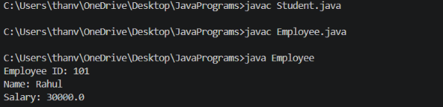

2. class Student {
int studentId;
String name;
int age;
void display() {
System.out.println("Student ID: " + studentId);
System.out.println("Name: " + name);
System.out.println("Age: " + age);
System.out.println();
}
public static void main(String[] args) {
Student s1 = new Student();
s1.studentId = 101;
s1.name = "Aryan";
s1.age = 18;
Student s2 = new Student();
s2.studentId = 102;
s2.name = "Veer";
s2.age = 19;
Student s3 = new Student();
s3.studentId = 103;
s3.name = "Keerthi";
s3.age = 18;
s1.display();
s2.display();
s3.display();
}
}
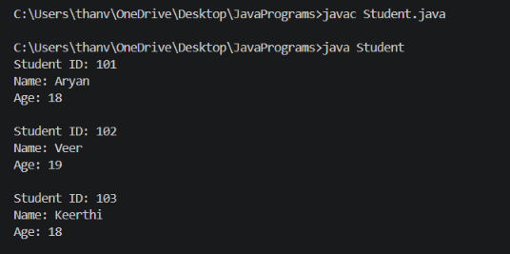
3. class Rectangle {
double length;
double width;

Rectangle(double l, double w) {
length = l;
width = w;
}

void calculate() {
double area = length * width;
double perimeter = 2 * (length + width);

System.out.println("Area: " + area);
System.out.println("Perimeter: " + perimeter);
}

public static void main(String[] args) {
Rectangle r = new Rectangle(10, 5);
r.calculate();
}
}

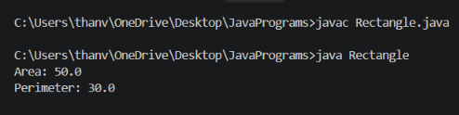
4. class Book {
int ISBN;
String title;
double price;
Book(int i, String t, double p) {
ISBN = i;
title = t;
price = p;
}
void display() {
System.out.println("ISBN: " + ISBN);
System.out.println("Title: " + title);
System.out.println("Price: " + price);
}

public static void main(String[] args) {
Book b = new Book(123456, "Java Programming", 450);
b.display();
}
}
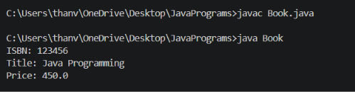

5. class BankAccount {
int accountNumber;
double balance;

BankAccount(int acc, double bal) {
accountNumber = acc;
balance = bal;
}

void deposit(double amount) {
balance = balance + amount;
System.out.println("Deposited: " + amount);
}

void withdraw(double amount) {
if (amount <= balance) {
balance = balance - amount;
System.out.println("Withdrawn: " + amount);
} else {
System.out.println("Insufficient Balance");
}
}

void display() {
System.out.println("Account Number: " + accountNumber);
System.out.println("Balance: " + balance);
}

public static void main(String[] args) {
BankAccount b = new BankAccount(12345, 5000);

b.deposit(2000);
b.withdraw(1000);
b.display();
}
}


